**Content**

1.0 Wind energy 1

1.1 Review sustainability in terms of CO2 saved 1

1.2 Environmental impact of the project 1

1.2.1 Noise pollution 1

1.2.2 Bird fatality 2

1.2.3 Bat fatality 3

1.3 The preventive measures needed in the construction process 5

2.0 Solar energy 7

2.1 Review sustainability in terms of CO2 saved 7

2.2 Environmental impact of the project 7

2.3 The preventive measures needed in the construction process 8

3.0 Tidal energy 8

3.1 Review sustainability in terms of CO2 saved 8

3.2 Environmental impact of the project 8

3.3 The preventive measures needed in the construction process 9

# **1.0 Wind energy**

## 1.1 Review sustainability in terms of CO2 saved

|  |  |  |  |  |  |  |  |
| --- | --- | --- | --- | --- | --- | --- | --- |
| **Wind** | **Italy** | **2006** | **2007** | **2008** | **2009** | **2010** | **2011** |
| **CO2 emission reduction per MWh** | [tCO2/MWh] | \ | \ | 0.4 | 0.4 | 0.4 | 0.4 |
|  | **Germany** |  |  |  |  |  |  |
| **CO2 emission reduction per MWh** | [tCO2/MWh] | 0.7 | 0.7 | 0.8 | 0.8 | 0.7 | \ |

Reference：(Marcantonini and Valero, 2017)

According to [Holttinen et al. (2014)](https://www.sciencedirect.com/science/article/pii/S0959652618329883" \l "bib20), this can be translated into 0.489–0.523 t CO2/MWh of [wind/solar](https://www.sciencedirect.com/topics/earth-and-planetary-sciences/solar-wind)generation approximately (Hernández *et al*, 2019).

|  |  |  |  |  |  |
| --- | --- | --- | --- | --- | --- |
|  | **Gas** | **Coal** | **Lignite** | **Offshore Wind** | **Onshore Wind** |
| **Emission Factor (tCO2/MWh)** | 0.400 | 0.925 | 0.875 | 0.00 | 0.00 |

Reference：(Dedecca *et al*, 2017)

Generating electricity from wind energy reduces the consumption of fossil fuels, and therefore results in GHG emission savings. A study conducted by Irish national grid found that the reductions in CO2 emissions, due to fossil fuel displacement by wind energy, range from 0.36 to 0.59 t CO2 per MW h [[61]](https://www.sciencedirect.com/science/article/pii/S1364032115004074#bib61). GWEC [[62]](https://www.sciencedirect.com/science/article/pii/S1364032115004074#bib62) reports that the 97 GW of wind energy capacity installed at the end of 2007 will save 122 million tonnes of CO2 every year, helping to combat [climate change](https://www.sciencedirect.com/topics/engineering/climate-change) (Wang and Wang, 2015).

## 1.2 Environmental impact of the project

### 1.2.1 Noise pollution

Noise is defined as any unwanted sound. [Wind turbines](https://www.sciencedirect.com/topics/engineering/wind-turbines) generate two types of noise: mechanical and aerodynamic. The mechanical noise is generated by the turbine׳s mechanical and [electrical parts](https://www.sciencedirect.com/topics/engineering/electrical-part), while the [aerodynamic noise](https://www.sciencedirect.com/topics/engineering/aerodynamic-noise) is generated by the interaction of blades with the air ([Fig. 3](https://www.sciencedirect.com/science/article/pii/S1364032115004074#f0015)). The noise emission from wind [turbine](https://www.sciencedirect.com/topics/engineering/turbines) is a combination of both (Wang and Wang, 2015).

Noise may have an effect on the fatality of species. Some bat species are known to orient toward distant audible sounds [[14]](https://www.sciencedirect.com/science/article/pii/S1364032115004074#bib14) and they could thereby be attracted to the sounds generated by the rotating blades, but there is no data to confirm this. Bats may also be attracted to the [ultrasonic](https://www.sciencedirect.com/topics/engineering/ultrasonics" \o "Learn more about Ultrasonics)noise produced by wind turbines [[15]](https://www.sciencedirect.com/science/article/pii/S1364032115004074#bib15). Observations using thermal infrared imaging suggest that bats do fly and feed in [close proximity](https://www.sciencedirect.com/topics/engineering/close-proximity) to wind turbines (Wang and Wang, 2015).

### 1.2.2 Bird fatality

Although wind power is generally considered environmentally friendly, the development of wind power has been associated with the death of birds colliding with turbines and other wind plant structures. Due to lack of understanding of the level of avian use at areas, some of early wind powers installations in the US caused relatively high risk of turbine collisions, because these facilities were located regions where birds were abundant [[17]](https://www.sciencedirect.com/science/article/pii/S1364032115004074#bib17). Due to the development of [standardized methods](https://www.sciencedirect.com/topics/engineering/standardized-method) for siting wind power [[18]](https://www.sciencedirect.com/science/article/pii/S1364032115004074#bib18) and monitoring for avian impacts [[19]](https://www.sciencedirect.com/science/article/pii/S1364032115004074#bib19), [[20]](https://www.sciencedirect.com/science/article/pii/S1364032115004074#bib20), many new developments have reduced the risk of turbine collisions. The bird fatalities range from 8–118 birds per year or 0.02–0.6 collisions per turbine per year ([Table 1](https://www.sciencedirect.com/science/article/pii/S1364032115004074#t0005))[[21]](https://www.sciencedirect.com/science/article/pii/S1364032115004074#bib21), [[22]](https://www.sciencedirect.com/science/article/pii/S1364032115004074#bib22), [[23]](https://www.sciencedirect.com/science/article/pii/S1364032115004074#bib23), [[24]](https://www.sciencedirect.com/science/article/pii/S1364032115004074#bib24). Raptors are found being more susceptible than other species. The European Wind Energy Association (EWEA) [[23]](https://www.sciencedirect.com/science/article/pii/S1364032115004074#bib23) reported that raptors showed some of the highest levels of mortality in both Altamont Pass, California, and Tarifa, Spain; this is due to their dependence on thermals to gain altitude, to move between locations and to forage. Some of them are long-lived species with low reproductive rates and thus more vulnerable to loss of individuals by collisions. Raptors are most affected (78.2%) during spring, followed by migrant passerines during post-breeding migration (September/October) [[23]](https://www.sciencedirect.com/science/article/pii/S1364032115004074#bib23). Other species reported include Eurasian griffon (*Cyps fulvus*)*,* Kestrel (*Falco tinnunculus*), Short-toed eagle (*Circaetus gallicus*) and Black kite (*Milvus migrans*). Barrios and [Rodriguez](https://www.sciencedirect.com/topics/engineering/rodriguez) [[25]](https://www.sciencedirect.com/science/article/pii/S1364032115004074#bib25)reported that the fatalities for Eurasian griffon (*Cyps fulvus*) were 0.12 per turbine per year, 0.14 per turbine per year for Kestrel (*Falco tinnunculus*), 0.008 per turbine per year for Short-toed eagle (*Circaetus gallicus*) and 0.004 per turbine per year for Black kite (*Milvus migrans*), respectively. There is, however, uncertainty in bird fatality measurements which have to be adjusted upwards, as scavengers are known to remove bird carcasses before researchers could discover them and researchers may miss carcasses, especially in agricultural landscapes and dense forest ridge tops (Wang and Wang, 2015).

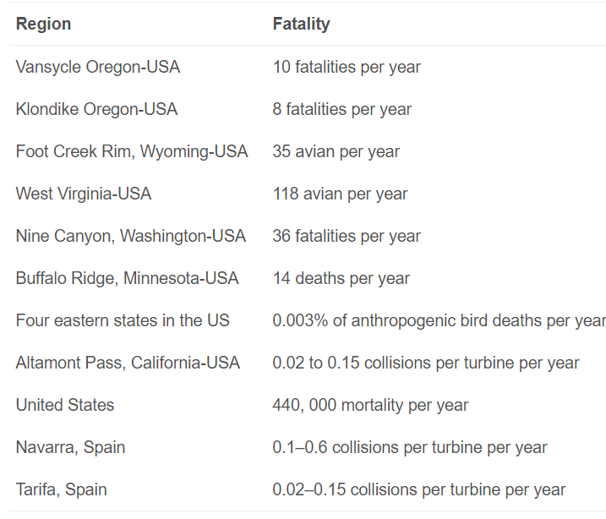

Reference：(Wang and Wang, 2015)

The avian mortalities of [wind farms](https://www.sciencedirect.com/topics/engineering/wind-farms) are very dependent on the season, weather, specific site (e.g. mountain ridge or migration route), topography, species (large and medium versus small, and migratory versus resident), type of bird activity (e.g. nocturnal migrations and movements from and to feeding areas). The main factors which determine the mortality of birds by collision in wind farms include landscape topography, direction and strength of local [winds, turbine design](https://www.sciencedirect.com/topics/engineering/wind-turbine-design)characteristics. However, it is still unclear how these factors impact the avian mortalities of wind farm and therefore efforts to understanding these are still needed (Wang and Wang, 2015).

### 1.2.3 Bat fatality

Bats will be killed by wind farms, especially by utility-scale wind energy facilities. Bat fatalities are reported to be relatively small before 2001 [[30]](https://www.sciencedirect.com/science/article/pii/S1364032115004074#bib30). This is largely because most [monitoring studies](https://www.sciencedirect.com/topics/engineering/monitoring-study) are designed specifically for bird fatality assessment and therefore bat fatalities are likely underestimated [[19]](https://www.sciencedirect.com/science/article/pii/S1364032115004074#bib19), [[26]](https://www.sciencedirect.com/science/article/pii/S1364032115004074#bib26). Recent monitoring studies indicate that large numbers of bat fatalities have been observed at utility-scale wind energy facilities, especially along forested ridgetops in the eastern US [[2]](https://www.sciencedirect.com/science/article/pii/S1364032115004074#bib2), [[21]](https://www.sciencedirect.com/science/article/pii/S1364032115004074#bib21), [[30]](https://www.sciencedirect.com/science/article/pii/S1364032115004074#bib30), [[31]](https://www.sciencedirect.com/science/article/pii/S1364032115004074#bib31), [[32]](https://www.sciencedirect.com/science/article/pii/S1364032115004074#bib32), and in agricultural regions of southwester Alberta, Canada ([Table 2](https://www.sciencedirect.com/science/article/pii/S1364032115004074#t0010)) [[32]](https://www.sciencedirect.com/science/article/pii/S1364032115004074#bib32), [[33]](https://www.sciencedirect.com/science/article/pii/S1364032115004074#bib33), [[34]](https://www.sciencedirect.com/science/article/pii/S1364032115004074#bib34), [[35]](https://www.sciencedirect.com/science/article/pii/S1364032115004074#bib35), [[36]](https://www.sciencedirect.com/science/article/pii/S1364032115004074#bib36), [[37]](https://www.sciencedirect.com/science/article/pii/S1364032115004074#bib37), [[38]](https://www.sciencedirect.com/science/article/pii/S1364032115004074#bib38), [[39]](https://www.sciencedirect.com/science/article/pii/S1364032115004074#bib39), [[40]](https://www.sciencedirect.com/science/article/pii/S1364032115004074#bib40), [[41]](https://www.sciencedirect.com/science/article/pii/S1364032115004074#bib41), [[42]](https://www.sciencedirect.com/science/article/pii/S1364032115004074#bib42), [[43]](https://www.sciencedirect.com/science/article/pii/S1364032115004074#bib43), [[44]](https://www.sciencedirect.com/science/article/pii/S1364032115004074#bib44), [[45]](https://www.sciencedirect.com/science/article/pii/S1364032115004074#bib45), [[46]](https://www.sciencedirect.com/science/article/pii/S1364032115004074#bib46), [[47]](https://www.sciencedirect.com/science/article/pii/S1364032115004074#bib47), [[48]](https://www.sciencedirect.com/science/article/pii/S1364032115004074#bib48), [[49]](https://www.sciencedirect.com/science/article/pii/S1364032115004074#bib49). Similar bat fatalities have been reported at wind energy facilities in Europe [[50]](https://www.sciencedirect.com/science/article/pii/S1364032115004074#bib50). The number of bats killed by wind energy facilities installed along forested ridgetops in the eastern US is reported ranging from 15.3 to 53.3 bats per MW per year, and the bat fatalities reported in southwester Alberta, Canada, are comparable to those found at wind energy facilities installed along the forested regions of the eastern US [[2]](https://www.sciencedirect.com/science/article/pii/S1364032115004074#bib2). The bat fatalities at the Buffalo mountain site are reported as 53.3 bats per MW per year at 3 small (0.66 MW) Vestas V47 wind turbines (Vestas Wind Systems A/S, Ringkobing, Denmark) and 38.7 bats per MW per year at 15 larger (1.8 MW) Vestas V80 wind turbines [[32]](https://www.sciencedirect.com/science/article/pii/S1364032115004074#bib32). The bat fatalities at Lewis County, New York, are estimated ranging from 12.3 bats to 17.8 bats per MW per year at 1.65 MW Vestas wind turbines, depending on carcass search frequency [[41]](https://www.sciencedirect.com/science/article/pii/S1364032115004074#bib41). Bat fatalities from regions of the western and mid-western US are relatively low, ranging from 0.8 to 8.6 bats per MW per year. This could be because many of these studies were designed only to assess bird fatalities [[19]](https://www.sciencedirect.com/science/article/pii/S1364032115004074#bib19). Like bird fatalities, bat fatalities may be underestimated, since scavengers can remove carcasses before researchers are able to recover them (Wang and Wang, 2015).

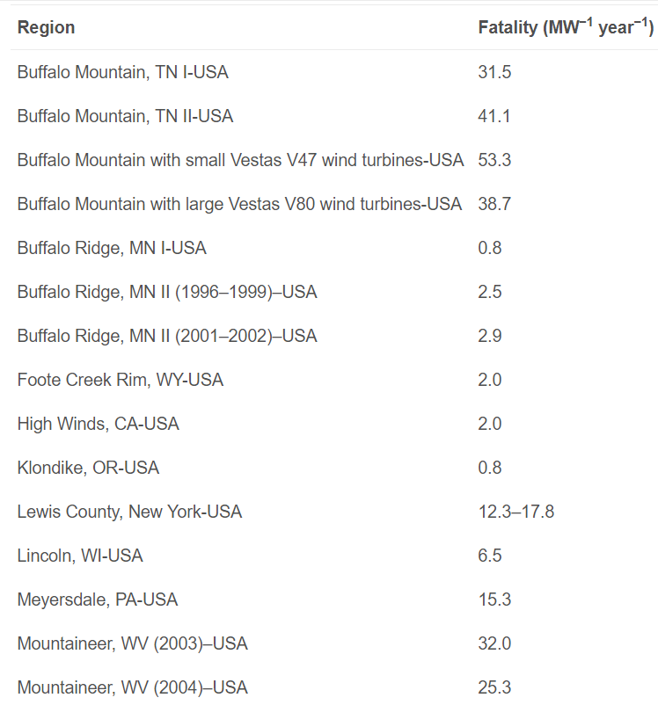

Reference：(Wang and Wang, 2015)

Bat fatalities of wind power vary not only with location, topography, but also with species and other factors. Bat species that migrate [long distance](https://www.sciencedirect.com/topics/engineering/longer-distance) are those most commonly killed at utility-scale wind energy facilities in the US [[2]](https://www.sciencedirect.com/science/article/pii/S1364032115004074#bib2). In North America, foliage-roosting, eastern red bats (*Lasiurus borealis*), hoary bats (*Lasiurus cinereus*) and tree cavity-dwelling silver-haired bats (*Lasionycteris noctivagans*), each of which migrate long distances, are identified at wind energy facilities [[2]](https://www.sciencedirect.com/science/article/pii/S1364032115004074#bib2). Other bat species killed by wind turbine in the US include the western red bat (*Lasiurus blossivilli*), Seminole bat (*Lasiurus seminolus*), eastern pipistrelle (*Perimyotis*[*=Pipistrellus*] *subflavus*), little brown myotis (*Myotis lucifugus*), northern long-eared myotis (*Myotis septentrionalis*), long-eared myotis (*Myotis evotis*), big brown bat (*Eptesicus fuscus*), and Brazilian free-tailed bat (*Tadarida brasiliensis*) (Wang and Wang, 2015).

Bats are struck and killed by the turning [rotor blades](https://www.sciencedirect.com/topics/engineering/rotor-blade) of wind turbines, and the factors increasing risk include the increasing height of wind turbines, the modifications of landscapes during installation of wind energy facilities, including the [construction](https://www.sciencedirect.com/topics/engineering/construction) of roads and power-line corridors and removal of trees to create clearings, the sound produced by wind turbines (though no evidence), the complex electromagnetic fields in the vicinity of nacelles produced by wind turbines, and weather conditions like low wind speed at night [[2]](https://www.sciencedirect.com/science/article/pii/S1364032115004074#bib2). It is, however, unclear why these factors increase the risk to bats. Potential explanations include: (1). The increase in height of wind turbine enlarges the danger area for bat and therefore increases the possibility of a bat, who migrates or forages at higher altitudes, touching the wind blades. (2). The modifications of landscapes may attract more bats around wind turbines, due to the creation of favourable environment for aerial insects upon which most insectivorous bats feed. (3). Some bats may be acoustically oriented or disoriented. (4). Some bats use receptors to guide fly. The complex electromagnetic field produced by wind turbines will interfere with perception in receptors. (5). The weather conditions such as cool and foggy conditions in valleys may make bats active along ridgetops, which will increase the likelihood of striking the moving wind turbine blades (Wang and Wang, 2015).

## 1.3 The preventive measures needed in the construction process

[Wind power](https://www.sciencedirect.com/topics/engineering/wind-power) is regarded as a promising [renewable energy](https://www.sciencedirect.com/topics/engineering/renewable-energy), and is growing rapidly worldwide. However, the deployment of wind power depends to a considerable degree on its [environmental performance](https://www.sciencedirect.com/topics/engineering/environmental-performance), and needs critical consideration. Although the deployment of wind power does cause noise emissions, the noise emissions from [wind farm](https://www.sciencedirect.com/topics/engineering/wind-farms) are smaller than those from city traffic ([Table 4](https://www.sciencedirect.com/science/article/pii/S1364032115004074#t0020)) [[58]](https://www.sciencedirect.com/science/article/pii/S1364032115004074#bib58). Noise emissions of wind farm can be further reduced through design of [wind turbines](https://www.sciencedirect.com/topics/engineering/wind-turbines), and careful location and planning of wind farms (Wang and Wang, 2015).

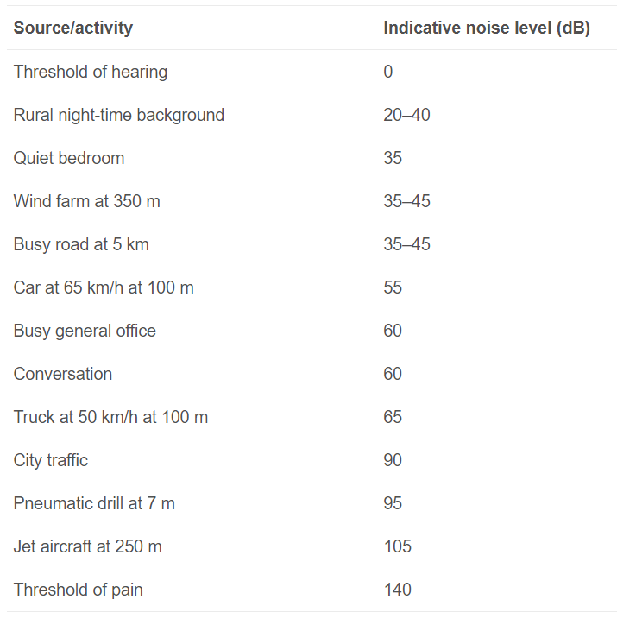

Reference：(Wang and Wang, 2015)

While the deployment of wind power will produce lower noise pollution levels than other ambient noises of human activity, generate far lower bird and bat fatalities than other human activities, and mitigate the GHG emissions, it may generate noticeable impacts on local to regional weather and climate if the area of turbines is large enough. The noticeable impacts may offset the benefits from the lower noise pollution levels, lower bird and bat fatalities, and mitigation of GHG emissions. This again calls for overall assessment of environmental impacts of wind power. Therefore, before the large deployment of wind power, more monitoring experiments, specifically for the overall assessment of environmental impacts, are still needed, in order to obtain the sustainable desirable [renewable energy sources](https://www.sciencedirect.com/topics/engineering/renewable-energy-source). The monitoring experiments should be designed (Wang and Wang, 2015).

Recently, due to the emergence of advanced [mechanical design](https://www.sciencedirect.com/topics/engineering/mechanical-design) (e.g. proper insulation to prevent mechanical noise from proliferating outside the [nacelle](https://www.sciencedirect.com/topics/engineering/nacelle) or tower, vibration damping), the mechanical noise has been reduced effectively, and is no longer considered to be as important as the aerodynamic noise, especially for utility scale wind turbines (Wang and Wang, 2015).

# **2.0 Solar energy**

## 2.1 Review sustainability in terms of CO2 saved

|  |  |  |  |  |  |  |  |
| --- | --- | --- | --- | --- | --- | --- | --- |
| **Solar** | **Italy** | **2006** | **2007** | **2008** | **2009** | **2010** | **2011** |
| **CO2 emission reduction per MWh** | [tCO2/MWh] | \ | \ | 0.4 | 0.4 | 0.4 | 0.4 |
|  | **Germany** |  |  |  |  |  |  |
| **CO2 emission reduction per MWh** | [tCO2/MWh] | 0.7 | 0.6 | 0.8 | 0.7 | 0.6 | \ |

Reference：(Marcantonini and Valero, 2017)

According to [Holttinen et al. (2014)](https://www.sciencedirect.com/science/article/pii/S0959652618329883" \l "bib20), this can be translated into 0.489–0.523 t CO2/MWh of [wind/solar](https://www.sciencedirect.com/topics/earth-and-planetary-sciences/solar-wind)generation approximately (Hernández *et al*, 2019).

Table 4. GHG results of mono-Si PV systems.

| **Location** | **GHG emissions (kg CO2,eq/kWh)** |
| --- | --- |
| UK | – |
| Japan | 61 |
| South-European | 41 |
| Switzerland | – |
| South-European | 30 |
| China | 50 |
| Lebanon | 89 |

Reference：(Kourkoumpas *et al*, 2018)

In 2013, GHG emissions of PV deployment are estimated at 55 gCO2-eqivalents (eq)/kWh ([Memmler et al., 2014](https://www.sciencedirect.com/science/article/pii/S0973082618308469" \l "bb0370)). Comparing these emissions with values from different studies, [Nugent and Sovacool (2014)](https://www.sciencedirect.com/science/article/pii/S0973082618308469#bb0390) calculated a mean of 49.9 gCO2-eq/kWh in a comprehensive literature analysis (Jenniches and Worrell, 2019).

## 2.2 Environmental impact of the project

PV solar plants represent environmentally clean source of energy. PV solar plant components (solar modules, inverters, monitoring system, conductors, etc) are manufactured by cutting edge, environmentally friendly technologies. PV solar plants operate noiseless, do not emit harmful substances and do not emit harmful electromagnet radiation into the environment. PV solar plant recycling is also environmentally friendly (Milosavljević *et al*, 2016).

## 2.3 The preventive measures needed in the construction process

# **3.0 Tidal energy**

## 3.1 Review sustainability in terms of CO2 saved

It is green: A side from being renewable, tidal energy is also an environmentally friendly energy source because it does not take up a lot of space and does not emit any [greenhouse gases](https://www.sciencedirect.com/topics/earth-and-planetary-sciences/greenhouse-gas) (Khare *et al*, 2019).

The emissions factor for the Cardiff-Weston barrage is estimated to be 2.42gCO2/ kWh, with a fgure of 1.58gCO2/kWh for the Shoots scheme (based on fgures for the English Stones scheme).

Reference：Tidal Power in the UK Oct07

## 3.2 Environmental impact of the project

A large number of thermal [power plants](https://www.sciencedirect.com/topics/agricultural-and-biological-sciences/power-plants) in operation and under construction are located in the coastal region to meet the increasing requirements of [electricity consumption](https://www.sciencedirect.com/topics/earth-and-planetary-sciences/electricity-consumption) in the development of coastal economy ([Zhao et al., 2013](https://www.sciencedirect.com/science/article/pii/S0304380014006140#bib0225)). Due to the limitation [of conversion efficiency](https://www.sciencedirect.com/topics/agricultural-and-biological-sciences/efficiency-of-conversion) of [heat engine](https://www.sciencedirect.com/topics/earth-and-planetary-sciences/heat-engine), a large amount of [waste heat](https://www.sciencedirect.com/topics/earth-and-planetary-sciences/waste-heat) is discharged into natural water body by thermal outfall from the power plants ([John, 1971](https://www.sciencedirect.com/science/article/pii/S0304380014006140#bib0090)). The initial mixing zone with high temperature occurs in the vicinity of the outfall ([Jiang et al., 2003](https://www.sciencedirect.com/science/article/pii/S0304380014006140#bib0080), [Tang et al., 2008](https://www.sciencedirect.com/science/article/pii/S0304380014006140#bib0170)). In the initial mixing zone, current and temperature may change greatly due to buoyant jets, which may result in profound [ecological effects](https://www.sciencedirect.com/topics/earth-and-planetary-sciences/ecological-effects), such as mortalities and low reproduction rate of certain fish species, local elimination of benthic animal, variation of [phytoplankton](https://www.sciencedirect.com/topics/earth-and-planetary-sciences/phytoplankton) [community structure](https://www.sciencedirect.com/topics/agricultural-and-biological-sciences/community-structure), and loss of biodiversity ([Poornima et al., 2005](https://www.sciencedirect.com/science/article/pii/S0304380014006140#bib0140), [Ingleton and McMinn, 2012](https://www.sciencedirect.com/science/article/pii/S0304380014006140#bib0075), [Li et al., 2014](https://www.sciencedirect.com/science/article/pii/S0304380014006140#bib0110)). [Algae](https://www.sciencedirect.com/topics/earth-and-planetary-sciences/alga), as an important link of ocean [food chain](https://www.sciencedirect.com/topics/earth-and-planetary-sciences/food-chain), is sensitive to variation of [ambient temperature](https://www.sciencedirect.com/topics/earth-and-planetary-sciences/ambient-temperature) (Zhao *et al*, 2015).

Present designs do not produce a lot of electricity, and barrages across river estuaries can change the flow of water and, consequently, the habitat for birds and other wildlife.

Barrages may block outlets to open water. Although locks can be installed, this is often a slow and expensive process.

Barrages affect fish migration and other wildlife. Many fish such as salmon swim up to the barrages and are killed by the spinning [turbines](https://www.sciencedirect.com/topics/earth-and-planetary-sciences/turbine).

Fish ladders may be used to allow passage for the fish, but these are never 100% effective.

Barrages may also destroy the habitat of the wildlife living near them.

Barrages may affect the tidal level—the change in tidal level may affect navigation and recreation while causing flooding of the shoreline and affecting local marine life (Khare *et al*, 2019).

Ocean transport, [tidal and wave power](https://www.sciencedirect.com/topics/engineering/tidal-power) generation activities affect marine organisms [[82]](https://www.sciencedirect.com/science/article/pii/S1364032117300965#bib82). Electromagnetic fields and underwater noise disturb marine life [[83]](https://www.sciencedirect.com/science/article/pii/S1364032117300965#bib83). When fishes pass through the [turbine blades](https://www.sciencedirect.com/topics/engineering/blade-turbine), they are injured in tidal and wave power plants. The tidal power plants change and modify wave and tide patterns at remote locations affecting the nearby environment [[84]](https://www.sciencedirect.com/science/article/pii/S1364032117300965#bib84). Ship and generator noise upsets underwater creatures. [Power generation](https://www.sciencedirect.com/topics/engineering/power-generation) equipments interfere with the navigational systems. Many marine creatures like turtles detect direction by the intensity of [magnetic fields](https://www.sciencedirect.com/topics/engineering/magnetic-fields) which can fail due to local magnetic fields [[85]](https://www.sciencedirect.com/science/article/pii/S1364032117300965#bib85). Marine reproduction is badly affected by exposure to electromagnetic fields and noise bursts [[86]](https://www.sciencedirect.com/science/article/pii/S1364032117300965#bib86). Marine animals migrate from high noise areas causing the environmental crisis. [Ocean energy](https://www.sciencedirect.com/topics/engineering/ocean-energy) is clean in nature, but can affect the local ecosystem (Khan *et al*, 2017).

As we know it, these facilities generate electricity with the use of tidal barrages that rely on ocean level manipulation, thus potentially having the same environmental effects as hydroelectric dams. Also, the turbine frames may potentially disrupt the natural movement of marine animals, and the [construction](https://www.sciencedirect.com/topics/engineering/construction) of the whole plant may also disturb fish migration (Khare *et al*, 2019).

Such as seismic surveys and drilling of anchor points. These activities will inevitably cause some physical disturbance, noise and increased turbidity but the construction phase will normally be quite short. Underwater noise is often identified as the main environmental concern during this phase with seismic surveys and pile driving being particularly noisy. Whilst installation of many tidal-stream device designs will not require pile driving, drilling of anchor points and armouring of cables using concrete mats or rock-dumping are also potentially noisy activities (Fox *et al*, 2018).

For example, tracking studies have shown that fish such as plaice (*Pleuronectes platessa*) and flapper skate (*Dipturus* cf *intermedia*) move up into the water column at certain times. Such vertical movements may be associated with feeding, spawning or the use of tidal streams for efficient horizontal movement [[59]](https://www.sciencedirect.com/science/article/pii/S1364032117309395#bib59), [[60]](https://www.sciencedirect.com/science/article/pii/S1364032117309395#bib60). Such species, which are normally assumed to be benthic, could therefore become exposed to [moving device](https://www.sciencedirect.com/topics/engineering/moving-device) components operating above the seabed at certain times (Fox *et al*, 2018).

While the additional noise from operating MREDs may alert animals to the presence of the devices and reduce collisions, excessive noise could result in the displacement of fish or marine mammals, potentially excluding them from important foraging areas [[6]](https://www.sciencedirect.com/science/article/pii/S1364032117309395#bib6), [[64]](https://www.sciencedirect.com/science/article/pii/S1364032117309395#bib64). However, tidally energetic sites often have high levels of ambient noise which may mask device-generated sound and vibrations [[63]](https://www.sciencedirect.com/science/article/pii/S1364032117309395#bib63). All MREDs also generate electromagnetic fields (EMF), principally around the sub-surface transformers and transmission cabling [[9]](https://www.sciencedirect.com/science/article/pii/S1364032117309395#bib9). EMF radiation may potentially impact chondrichthyan fishes in particular (Fox *et al*, 2018).

The introduction of new [underwater structures](https://www.sciencedirect.com/topics/engineering/underwater-structures) to the marine environment undoubtedly has the potential to modify local predator-prey interactions. Existing underwater structures frequently attract fish from the surrounding area [[70]](https://www.sciencedirect.com/science/article/pii/S1364032117309395#bib70), [[71]](https://www.sciencedirect.com/science/article/pii/S1364032117309395#bib71), [[72]](https://www.sciencedirect.com/science/article/pii/S1364032117309395#bib72) and such local increases in potential prey can then attract larger predators (Fox *et al*, 2018).

## 3.3 The preventive measures needed in the construction process

Other mitigation measures developments have included avoiding construction during sensitive times of the year, for example during the spawning season of Atlantic herring *Clupea harengus*[[42]](https://www.sciencedirect.com/science/article/pii/S1364032117309395#bib42). Increased shipping, for example moving of components from overseas ports, also brings about an [increased risk](https://www.sciencedirect.com/topics/engineering/increased-risk) of introduction of invasive species. Biosecurity planning therefore needs to be implemented to mitigate this risk (Fox *et al*, 2018).